Fall 2023 Spring 2024
Career Health Connections is a program designed for students who are interested in pursuing or learning more about health careers. Students will attend 1 Educational/Orientation Session and 8 weeks of on site learning at Virtual Medical Center, Wilson County Substance Abuse Coalition, Carolina Family Health Centers, Wilson Medical Center and Wilson County Emergency Medical Services .

Selected students will receive the following program benefits:
- Hands-on involvement with healthcare professionals
- Exposure/entry into 8 different healthcare service areas
- Opportunities to make connections with staff, Introductions to organization leaders
- HIPPA, diversity and equity training - resume builder for college or job applications
- A Youth Health Service Corps Certificate through Area L AHEC (if all hours are completed)
- A Career Health Connections Program Certificate
- $100 Scholarship if you complete the program

What are the program dates? Fall 2023 September 20 - November 15
Spring 2024 January 31 - March 27
What time of day? Every Wednesday 3:00 p.m. - 5:00 p.m.
What if I cannot make all the days? You are allowed 1 absence to earn a CHC Certificate
Do I need my own transportation? Yes
What do I need to submit with my application?
- 2 Teacher Reference Forms (Attached to this document)
- Copy of Covid Vaccine Card
- Copy of Current Flu Shot

CDC’s Beddingfield * Athena Bynum * Hunt Lisa Hendricks * Fike Jean Hall

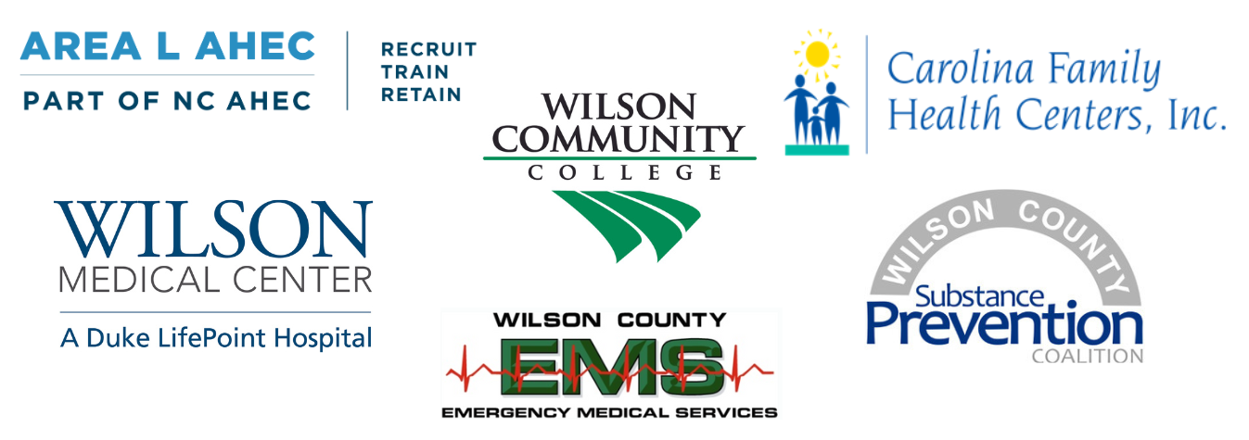

Wilson Education Partnership - Career Health Connections Application
(Please type or print)
Name_______________________________________ Cell Phone #_______________________
Address_______________________________________________________ Shirt Size ________

Email_______________________________________ School _______________ Grade______
Emergency Contact Name__________________________ Phone #_______________________
In 5-7 sentences , tell us why you would like to participate in this program.
_____________________________________________________________________________________________________________________________________________________________________________________________________________________________________________________________________________________________________________________________________________________________________________________________________________________________________________________________________________________________________________________________________________
Please include 2 references with your application. Forms are included.
I give ________________________________ permission to participate in this program, have a background check, and fill out a health eligibility screening. I give permission for Wilson County Schools to release his/her medical records to Carolina Family Health Centers and Wilson Medical Center if needed. I understand that transportation is the responsibility of the student.
___________________________________________________________________
Parent/Guardian Date
___________________________________________________________________
Student Date
______________________________________________________________________________

WEP Career Health Connections Teacher Reference Form

Name of Applicant: ____________________________________________________________

Please mark as appropriate:

(1 – Poor, 2 – Fair, 3 – Good, 4 – Outstanding; N – No, Y – Yes, X- Cannot Evaluate)

1. | Class Attendance |  |  | 1 | 2 | 3 | 4 | X
2. | Academic performance |  |  | 1 | 2 | 3 | 4 | X
3. | Classroom behavior |  |  | 1 | 2 | 3 | 4 | X
4. | Willingness to accept responsibility |  |  | 1 | 2 | 3 | 4 | X
5. | Dependability/reliability |  |  | 1 | 2 | 3 | 4 | X
6. | Ability to work with others |  |  | 1 | 2 | 3 | 4 | X
7. | Knowledge of class content |  |  | 1 | 2 | 3 | 4 | X
8. | Initiative/work ethic |  |  | 1 | 2 | 3 | 4 | X
9. | Respect for authority |  |  | 1 | 2 | 3 | 4 | X
10. Ability to follow written/oral directions |  |  |  | 1 | 2 | 3 | 4 | X
11. Student is academically prepared to be |  |  |  |  |  | N | Y | X
 | successful in an internship program.
12. Student is personally prepared to be successful |  |  |  |  |  | N | Y | X
 | in an internship program.
I recommend this student: |  | _____ without reservations
 |  | _____ with reservations
 |  | _____ cannot recommend

Signed _____________________________________ Date______________________

