**  **

**Fall 2024 and Spring 2025**

Career Health Connections is a program designed for students who are interested in pursuing or learning more about health careers. Students will attend 1 Mandatory Educational/Orientation Session, 1 field trip and 7 weeks of rotations in Wilson Medical Center and Carolina Family Health Centers.

**Selected students will receive the following program benefits:**

* Hands-on activities in different healthcare service areas
* Opportunities to make connections with staff and meet organization leaders
* HIPPA, diversity and equity training certificate - resume builder for college or job applications
* Narcan Training
* Service Learning Certificate
* Career Health Connections Program Certificate

**What are the program dates?** Fall 2024 September 18 - November 13

Spring 2025 January 29 - March 26

Field Trip September 25, 2024 7:30 am - 5:30 pm Field Trip January 22, 2025 7:30 am - 5:30 pm

**What time of day for rotations?**  Every Wednesday 3:00 p.m. - 5:00 p.m.

**What if I cannot make all the days?** You are allowed 1 absence to earn a CHC Certificate

**Do I need my own transportation?** Yes

**What do I need to submit with my application?**

* Copy of Covid Vaccine Card or Waiver Paperwork (provided by WEP) Religious or Health Reasons
* Copy of Current Flu Shot

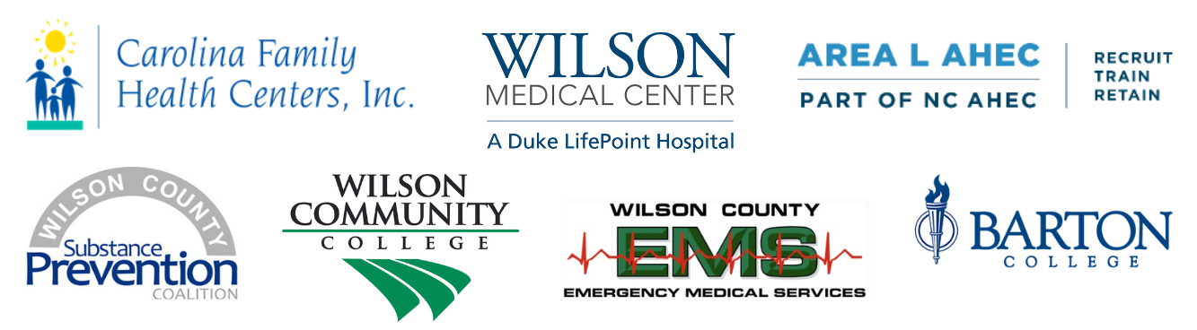

***Wilson Education Partnership -*** ***Career Health Connections Application***

***(Please type or print)***

**Fall 2024 _______ Spring 2025 _______**

**Name**_______________________________________ **Cell Phone** #_______________________

**Address**_______________________________________________________ **Shirt Size** ________

**Birthdate**________________ **Email**_______________________________________

**School** _______________ **Grade**______

**Emergency Contact Name**__________________________ **Phone** #_______________________

My flu shot is attached__________

Copy of Covid Vaccine Card is attached_________

I did not get the COVID vaccine. Please email me a waiver form for Religious or Health Reasons_______

**Hard Copy with original signature needed**

I give ________________________________ permission to participate in this program, have a background check if needed, fill out participating facility paperwork, attend an all day field trip, and fill out surveys from program participants. I give permission for Wilson County Schools to release his/her medical records to WEP, Carolina Family Health Centers and Wilson Medical Center if needed. I understand that transportation is the responsibility of the student. **Parent signature needed if student is under 18**

Parent/Guardian Date

___________________________________________________________________

**All student participants must sign below.**

I agree to be on time, wear appropriate clothing and identifying name badge, follow facility rules, not use my cell phone during rotations, and notify WEP Executive Director if I will not be attending one day. I understand if I am late one day, I may not be able to finish the program. I understand that WEP will provide shirts, name badges and a lanyard. I am only allowed 1 excused absence to receive the $100 scholarship and program certificate. I understand the first day is a mandatory orientation and if I cannot attend I will not be able to participate.

I have the following food allergies________________________________________________. Please write N/A if none.

Student Date

____________________________________________________________________